Theme Development

01 Theme dev

Place holder Screenshot

Tony Evans

See next page for screenshots of what your page should look like

The contents of this folder should look like the following:

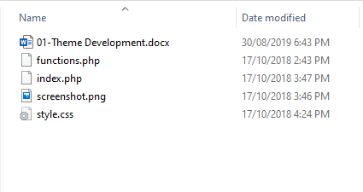

Activate this theme and this is how your site should look as a new theme in the 01-Theme Development folder. Looks like it needs styling and a lot more.

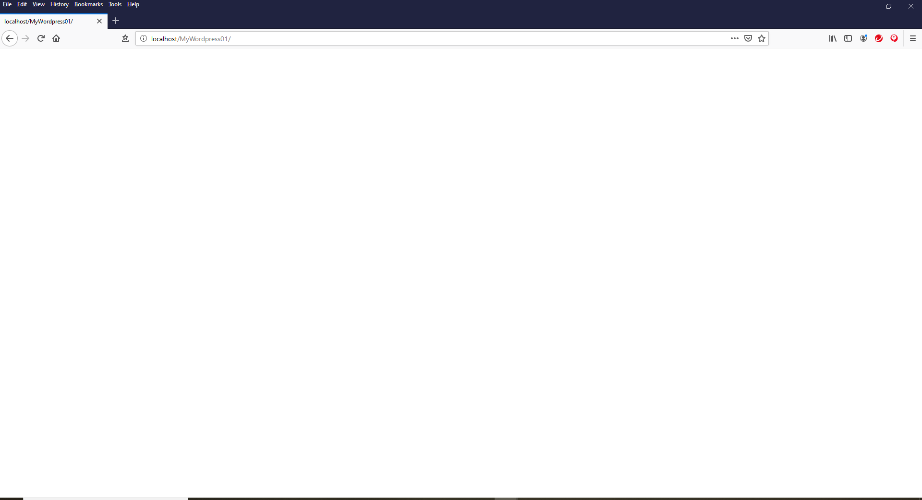

There should be nothing on the page and nothing in the developer tools apart from the default html.

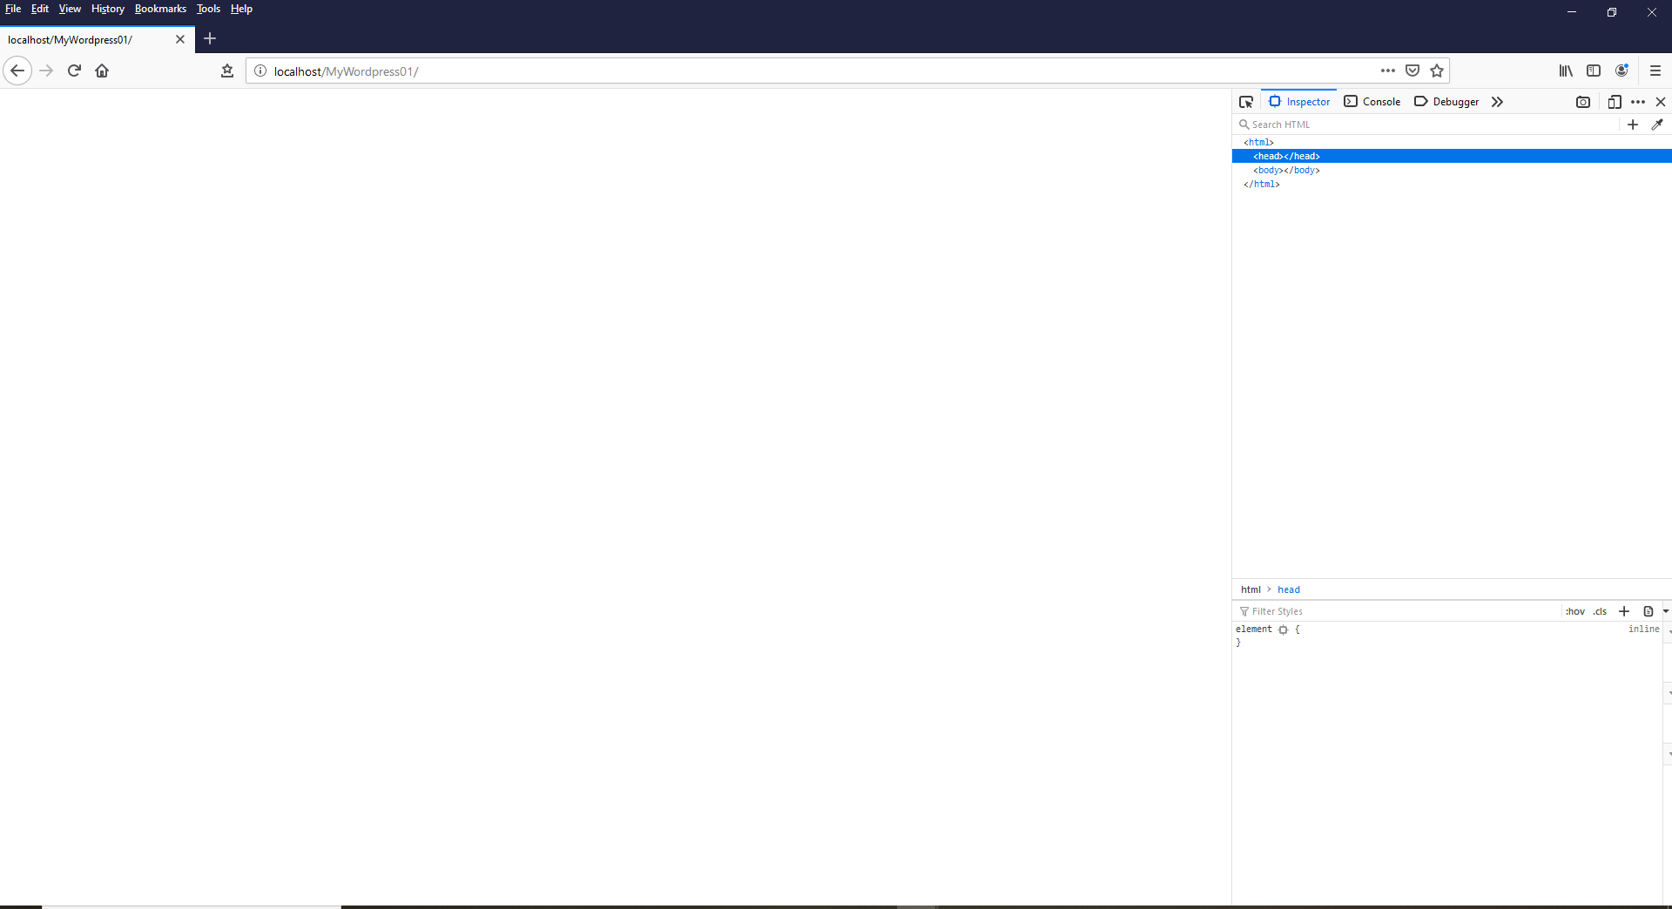

Closer look

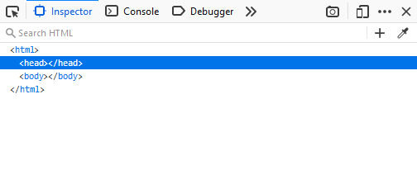

Don’t panic! We can start to work on the next steps, but before we do, lets have a look at the files in this folder. The first file is the “style.css”. As with the Child theme development, this file is the main page for WordPress. And should look like the following screen shot.

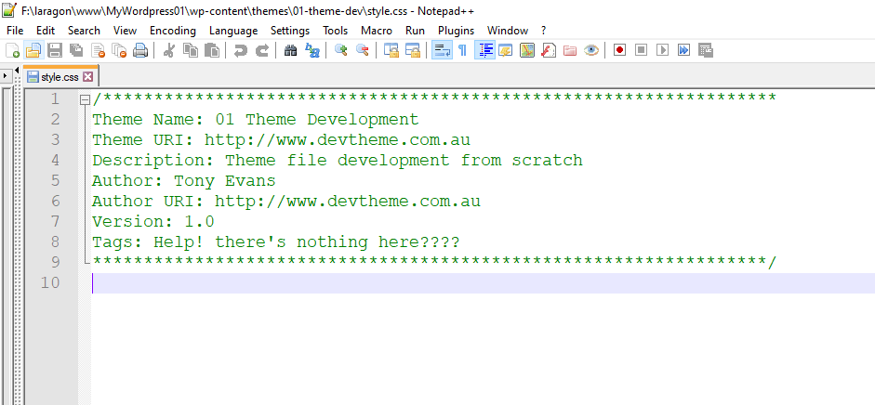

The comments in WordPress style sheet are used for the name and any other info for the theme in the themes area of the Administrator section.

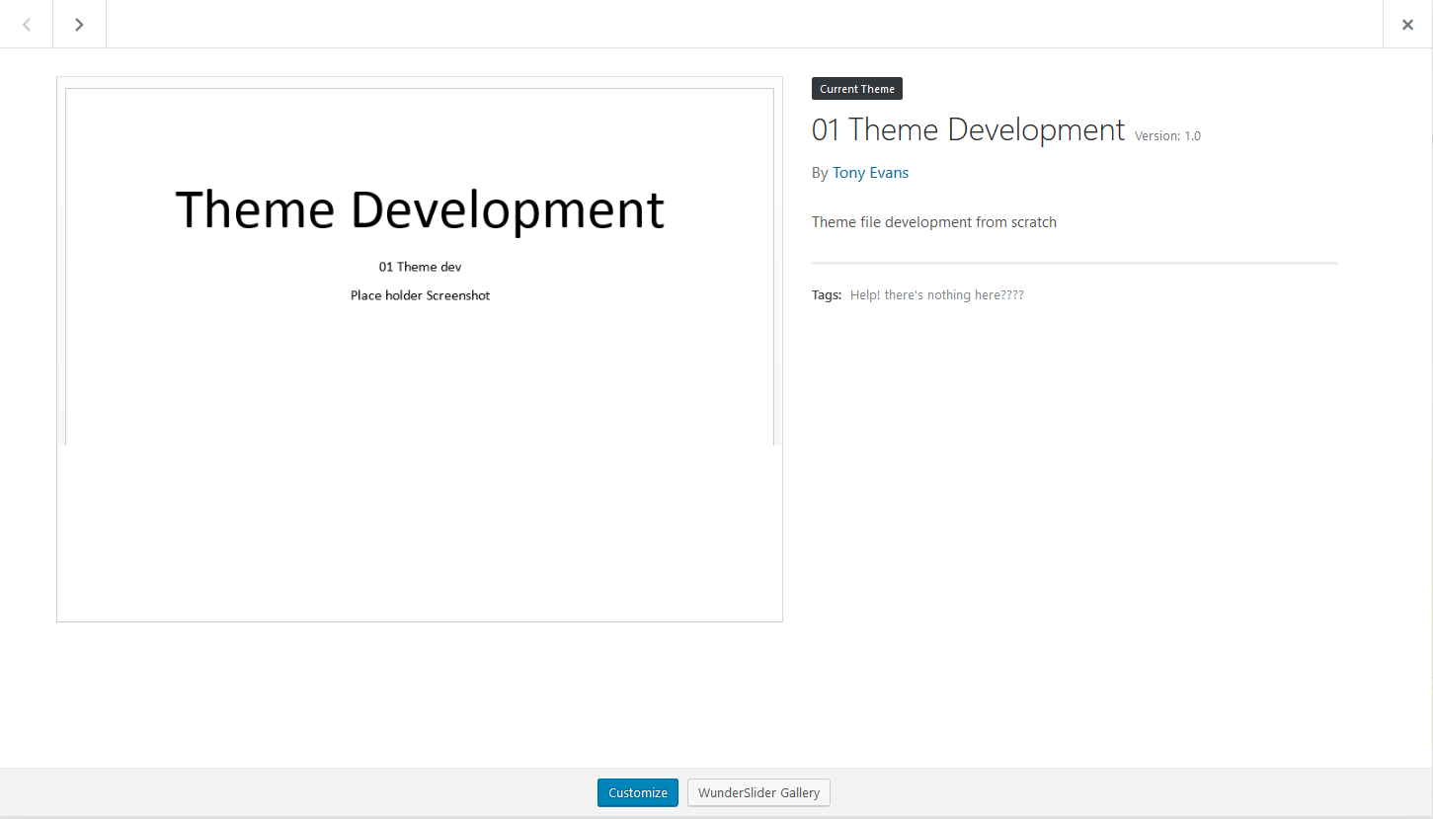

The “functions.php” file has nothing in this either. This is where you will place the “enqueue style” function and any other functions that you would want to run or disable.

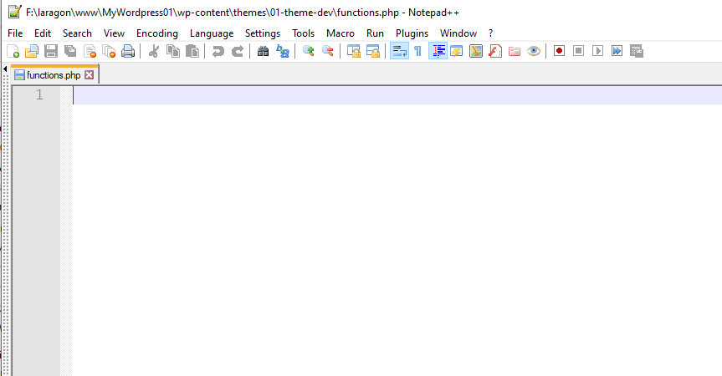

The “index.php” also has nothing in it, so it is really starting with a blank slate.

See “02-Theme Development” for the next steps.